
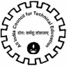

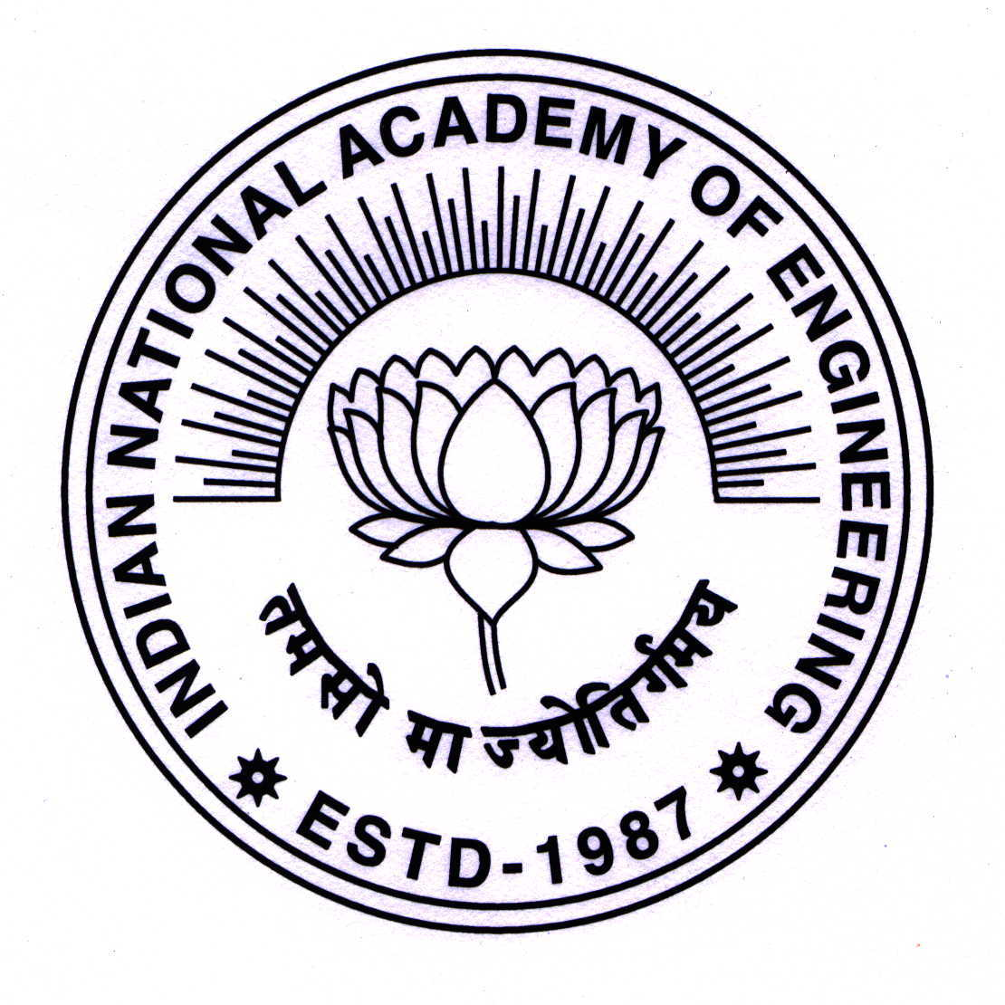


Indian National Academy of Engineering National Innovation Council All India Council for Technical Education
Government of India

1st University-Industry Congress
& 3rd Global Higher Education Summit
14th – 15th November 2011, Hotel Lalit, New Delhi

Tentative Programme

DAY I: 14th November 2011
0900 – 1000 hrs | Registration & Tea

1000 –1015 hrs | Opening Address: Ms. Vibha Puri Das  Secretary – Higher Education  Ministry of Human Resource Development
1015 –1130 hrs | Session 1: Whose Stakes are Higher in Academia-Industry Collaborations?  The disconnect between industry and university in India is there for all to see. Year after year studies are conducted to highlight just one small point—our graduates, specially engineering graduates, are largely unemployable. This is the result of outdated curricula, academia being out of sync with ground realities and little practical exposure to students. Even while this is so, both industry and universities are reluctant to reach out to each other. Who is the greater loser in this war?
1130 – 1200 hrs | Tea / Coffee break
1200 – 1400 hrs | Session 2: Building a Digital Fortress  The requirements of 21st century call for 21st century solutions. Building hundreds of universities and thousands of colleges to increase the gross enrolment ratio to 30 per cent is desirable but not immediately possible. Technology can be used in the interim to bridge the gap between the haves and the have-nots. The Government is already building a digital knowledge highway—the National Knowledge Network--which the private sector can utilize by creating content for the users. How will the partnership develop? What do private players need to do to get on to the knowledge highway? How can technology be used to bridge the knowledge divide?
1400 – 1500 hrs | Lunch
1500 – 1530 hrs | Assemble for Inaugural

Indian National Academy of Engineers National Innovation Council All India Council for Technical Education
Government of India

University-Industry Congress
& 3rd Global Higher Education Summit
14th – 15th November 2011, Hotel Lalit, New Delhi

Inaugural Session

1530 – 1540 hrs | Welcome remarks and  moderated by | Mr P Rajendran*  Chairman, CII National Committee on Higher Education (2011-2012) & Co-founder & COO, NIIT Ltd.
1540 – 1550 hrs | Address | Dr Y S Rajan*  Dr. Vikram Sarabhai Distinguished Professor  ISRO
1550 – 1600 hrs | Address | Dr Ved Prakash  Chairman  University Grant Commission
1600 – 1610 hrs | Address | Mr Mel Wong*  Assistant Deputy Minister  Alberta Advanced Education and Technology, Canada
1610 – 1625 hrs | Inaugural Address by  the Chief Guest | Mr Kapil Sibal*  Hon’ble Minister for Human Resource Development, Government of India
1625 – 1630 hrs | Closing Remarks | Mr Suresh Elangovan*  Member CII National Committee on Higher Education & Founder, CEO & MD  Mindlogicx Infratec Limited

1630 – 1700 hrs | Tea Break
1700 – 1830 hrs | Session 3: Moving towards Corporate Universities  The best way of increasing interaction between industry and academia is to allow large manufacturing and technology companies such as in automobile, machinery manufacturing, pharmaceuticals and information technology sectors to set up engineering and technical institutes inside their premises so that there is greater interaction between industry and academia. What stops that from happening now—regulations that need to be changed. If Indian industry creates the infrastructure, foreign universities can provide services. Big multinational companies with large operations in India such as GE, Motorola and Ford can set up universities where both Indian and foreign universities can provide the knowledge support.

DAY II: 15th November 2011

0900 – 1000 hrs | Registration & Tea
1000 – 1130 hrs | Session 4: What does Industry Want from Academia and What does Academia Expect from Industry?  The session will be conducted in two parts with the first half being devoted to industry’s expectations and second half to academia’s aspirations.  Academia believes it exists only for creation of knowledge and has no connection with wealth, industry believes its job is to create wealth and not worry about generation of knowledge. The two may like to think they are independent but in fact they are both inter-dependent. What are the industry’s expectations from academia? What kind of manpower, human resource does it want? Should academia prepare the base for acceptance of candidates in industry or should it look into grooming them for niche requirements of different players?
1130 – 1200 hrs | Tea / Coffee Break
1200 – 1330 hrs | Academia’s expectations from industry should not be limited to providing placements to its students. They should go deeper than that—there is curriculum development, faculty development, industrial visits, joint research, product development. If all this is not happening in India at a broad level now then why is it not happening? What are the major roadblocks from academia’s perspective? How have foreign universities tackled this problem?
1330 – 1430 hrs | Lunch

1430-1600 hrs | Session 5: Companies Inside Institutes and Research Partnerships  R&D spend by industry in India is negligible. One way of spurring research activity in both industry and academia is for the government to fund R&D infrastructure in industry and If institutes set up inside the premises of companies can benefit from the practical exposure they get, equal benefit can be derived by companies set up inside the premises of institutes. Research and collaboration becomes easier and incubation of other start-ups gets a spur. There are numerous examples of such companies in the West—the entire Silicon Valley grew out of Stanford University. In India how can research partnerships develop in a manner that the government funds R&D labs in companies and research scholars are employed by the industry.
1600 hrs | Tea & Close

